1. Assignment 22,26 Day3(InfyTQ)

Problem 2

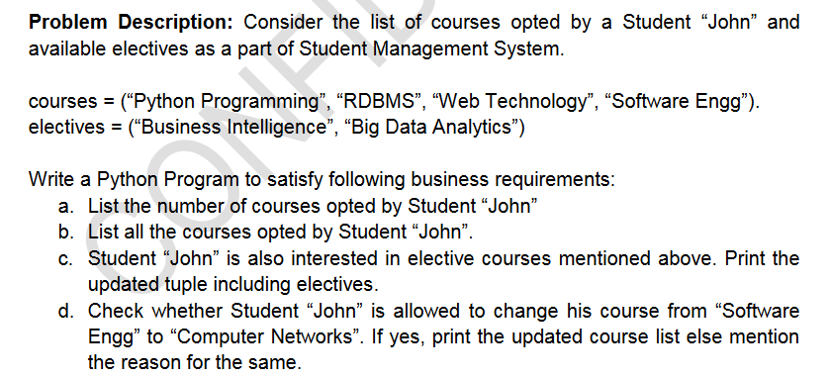

Problem 3****

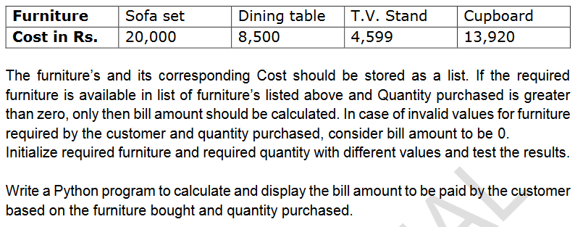

1. **Implement a stack using list**